## Department of Chemical Engineering, IIT Kharagpur

## Fluid Mechanics (CH 20001) Mid-Semester Examination, 2016-17

## 2nd year B.Tech (H)/M.Tech (Dual) No. of Students 87, Time 2 Hrs., Full Marks 30

## Open Book Examination

## Only the two textbooks by the following authors are allowed:i) Fox & McDonald and ii) Bird Stewart & Lightfoot

## Any other book(s), photocopies of text books and class notes are not allowed

There may be handwritten notes on the pages of the book, but sharing of books is NOT allowed.

**Q1.** When a liquid is subjected to a pressure increase, the volume decreases by some extent, and as a result the density increases. For sea-water, assume that the pressure volume relation is linear, and the proportionality constant between the change in pressure, and the corresponding fractional change in specific volume ( $E_{V}=-\frac{dP}{\frac{dV}{V}}$) is 2.33×103 MPa. If the pressure in the deepest part of the ocean is 110 MPa, find the fractional increase in density over the sea level value. **6 Marks**

**Q2.** Calculate the capillary rise of water in a pair of glass plates, separated by 2 mm, if the plates are inclined at 75° from the vertical. Assume air-water surface tension is 0.073 N/m, and contact angle for air water glass system as 0°. **3 Marks**

**Q3.** When is an Eulerian formulation inappropriate? In the two-dimensional incompressible flow field, the velocity components are expressed as ; 

Calculate the stream function and the discharge between streamlines passing through the x-y coordinates (1, 3) and (2, 3) **1+2+3=6 Marks**

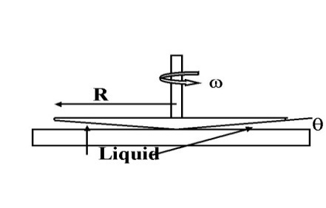**Q4.** The cone and plate viscometer consists of a flat plate and a rotating cone with a very obtuse angle (typically θ less than 0.5 degrees, making it reasonable to assume a linear velocity profile locally, i.e. at any r). The apex of the cone just touches the plate surface and the liquid to be tested fills the narrow gap formed by the cone and the plate. Derive an expression for the shear rate in the liquid that fills the gap in terms of the geometry (R, θ) and angular velocity (ω) of the system. Evaluate the torque in terms of the shear rate and geometry of the system. Assume that there is no mixing in the r and φ direction. **7 Marks**

**Q5.** The airways in the lung are covered with a thin liquid lining. Gravity acts to pull this fluid down into the lung, while the cilia in the upper airways pump this fluid upward. However, in the lower airways, there are few cilia and surface tension becomes more important in this balance. During a cough, air motion can be important.

Assume an artery of diameter 2 mm and a liquid lining of 10 µm (thin enough that the curvature of the liquid lining can be neglected in this problem). Ignoring effect of the cilia and surface tension, what flow rate of air is necessary to cause all of the fluid in the liquid lining of this airway to move upward during a cough? The viscosity of the liquid lining is 1x10 - 3 Pa.s and its density is 103 kg/m3; whereas the viscosity of air is 1.9 x 10 - 5 Pa.s.

Assume steady state conditions. When considering the boundary condition at the interface between the moving air and the airway liquid, recall that the flow of the air is affecting the flow of the liquid by imposing a nonzero shear. Additionally, the flow of air requires a pressure gradient in the air (and hence in the liquid), denoted by γAir, in the figure. Cite specific reasons why this pressure gradient can be neglected for the liquid phase in the formulation of the problem. **8 Marks**